**Sri Lanka Institute of Information Technology**

**IT3021- Data Warehousing and Business Intelligence**

**Assignment 02**

**Student Registration No: IT20188054**

**Student Name: Benthota Arachchi B.A.T.P.**

**Batch: Y3.S1.WE.DS.04**

Table of Contents

Step 1 – Data Source for the Assignment 3

Step 2 – SSAS Cube Implementation 4

Step 3: Demonstration of OLAP operations 12

Step 4: SSRS Reports 16

# Step 1 – Data Source for the Assignment

For the data source, the data warehouse database “Electricity_Management_DW” was selected which was previously created in Assignment 1.

The fact table and Dimension tables,

1. FactPowerConsumptionCharges – Fact Table
2. DimPowerDistribution
3. DimPowerPlant
4. DimPowerSupplier
5. DimPowerUnit
6. DimConsumer
7. DimDate

Also, the data warehouse follows the snowflake schema to integrate them. Those fact and dimension data were used to create OLAP cubes and generate OLAP operations in Excel and prepare reports in Report Builder.

# Step 2 – SSAS Cube Implementation

* Used Tools: -

SSAS

SQL Server Management Studio

SSDT

* 1. **Create the SSAS Project**

When creating the OLAP cubes first, created Analysis Services Multidimensional and Data Mining Project on SSDT. Then renamed it “*ElectricityManagement_SSAS*”.

* 1. **Create a Data source**

Under the Data Sources folder in the above folder structure, a data source file was created.

In the data source file, a new connection was defined with the Data warehouse “Electricity_Management_DW”. And as the authentication to the data warehouse new login is created in the data warehouse which connects to the data analysis service instance assigned to the windows authentication.

* 1. **Create a Data Source View**

Under the Data Source Views folder, Added a new data source view called DSV Electricity Management DW.

* 1. **Create a Cube**

Under the Cubes folder, created a new cube using the above data source.

Then all the relevant attributes were selected from the dimensions and created a hierarchy in the cube of relevant dimensions

* These are the 2 hierarchies that were created,

* the folder structure after the above structure,

* 1. **Deploy the Cube**

After finishing all the above steps, the cube is deployed. If it is successfully deployed a message is displayed signifying deployment’s success as shown below.

* 1. **Create KPI**

KPIs are developed based on the needs of the company. It is a measurable value that shows how well a corporation accomplishes essential business objectives. KPIs are used by businesses to assess their progress toward achieving their objectives.

The following Figure shows the KPI which I created after the deploying cube. These are the KPI values created for power consumption. It can be used for determining how much consumers paid more than 10000

* 1. **Browse Cube Data**

Browsing data is done via using SSMS. By connecting SSAS to SSMS using instance and MDX queries can generate by selecting the relevant fields from the dimensions.

The below figure shows how to browse data in SSMS,

# Step 3: Demonstration of OLAP operations

* Used Tools:-

Excel

SQL Server Management Studio

SSAS

To display the OLAP operation first, the Excel is connected to the SSAS cube using the MDX query. MDX query is created using the above process. And below picture shows how to connect the Excel to SSAS Cube successfully.

Then, this shows how to successfully insert a sample MDX query for generating data to create OLAP operations.

**Slice**

Slices are visual filters that can be used to filter data in a pivot table or chart. For the pivot table and pivot chart, I utilized two slices, one for each. The slices I used to filter my pivot table and pivot chart are shown in the diagram below.

**Dice**

Selecting appropriate qualities to group the data by is referred to as dicing the data.

To analyze the data in the pivot table and pivot chart, I utilized two slicers. Those are power supplier slicers and location slicers.

**Roll-up**

Climbing up a hierarchy of a dimension to aggregate data is what the Roll up OLAP function in cubes signifies.

**Drill-Down**

In cubes, the drill-down OLAP function entails navigating through details by moving down a hierarchy of a dimension.

# Step 4: SSRS Reports

**Used Tools**:-

Report server

SSRS web portal

Report Server Configuration Manager

Report Server database

Microsoft Report Builder

The below figure shows the web portal view. In there, the created paginated reports and SSRS folder are displayed.

**Report 1: Report with a matrix**

The below figure shows rows and columns designed according to the report

Report shows all the power supplier companies year wise sales price and sub total amounts according to power consumption market.

And the pie chart shows year-wise total amount prices percentages of power suppliers.

**Report 2: Report with more than one parameter.**

This report used three parameters of Gender, Race, and Type of the consumer. And multiple options can be selected in the parameter.

Then, the selected value from the Gender, Race, and Type drop-down, relevant details related to those parameter values are displayed. Also inside the parameter default values are created for the efficiency of retrieval of the report

The below figures show three parameters and the result report.

**Report 3: Create an SSRS drill-down report.**

**Report 4: Create an SSRS drill-through report.**

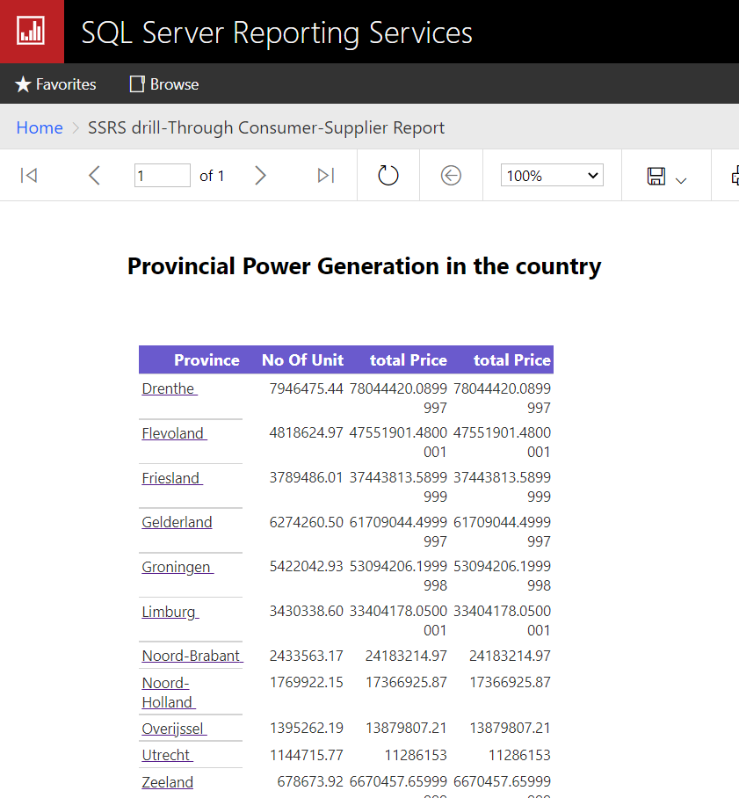

When you select the province, the system will redirect it to power suppliers who distribute under the selected province

